Machine Description | A deliberately vulnerable lab machine for practicing web app exploits, privilege escalation, and post-exploitation to gain user and root access.
Target IP | 192.168.0.142
Vulnerability Name | • SQL Injection (SQLi)  • Remote Code Execution  • Outdated Linux Kernel Privilege Escalation
Port / Service | TCP 80 / http
Severity | High 8.4
Attack Vetor | CVSS:3.0/AV:L/AC:L/PR:N/UI:N/S:U/C:H/I:H/A:H
Proof of Concept (PoC) | STEP 1 – Nmap to find the IP of the target machine.  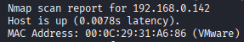  STEP 2 – Nmap Scan to discover open ports and Services  # nmap –p- -sC –sV $ip –open  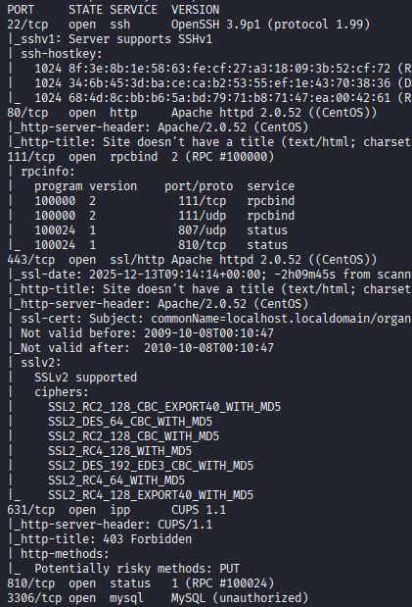  STEP 3 - Found a Login page on port 80  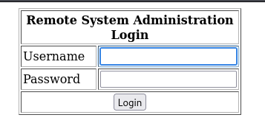  STEP 4 - Did a SQLi attack  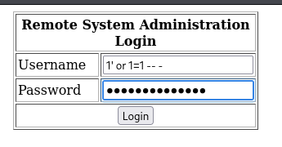  STEP 5 - We are in !  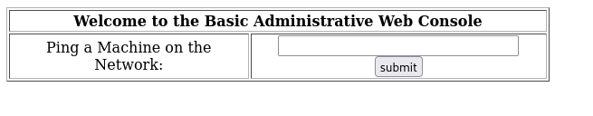  STEP 6 - We have code execution  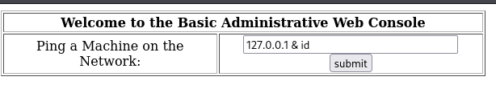  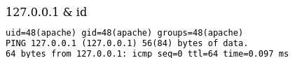  STEP 7 – Got a shell and stabilized it.  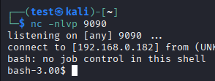  STEP 8 - Found the Kernal version  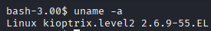  STEP 9 - Found Kernel exploit, there are 2 exploit but we will go for Distro specific i.e. centOS (Exploit name – 9542.c)  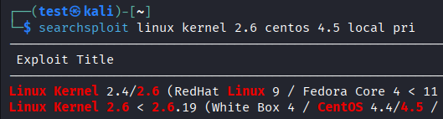  STEP 10 – Compliers are present  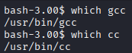  STEP 11 - Transferred the exploit using http server  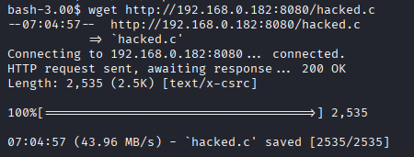  STEP 12 - Compiled it  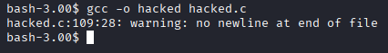  STEP 13 - We have root!!  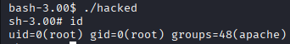
Remediation | • Validate and sanitize all user inputs to prevent SQL Injection  • Use prepared statements / parameterized queries  • Keep the operating system and kernel updated  • Remove unnecessary compilers and tools from production servers  • Restrict file upload and command execution permissions  • Use a Web Application Firewall (WAF)
Impact | • Attackers can bypass the login page without knowing a password  • Full control over the website can be achieved  • Attackers can run malicious commands on the server  • System access can be escalated to root (administrator) level  • Can lead to data theft, data modification, or complete system takeover
References | https://owasp.org/www-community/attacks/SQL_Injection  https://owasp.org/www-project-top-ten/

